INDAVIUVAL NETWORK

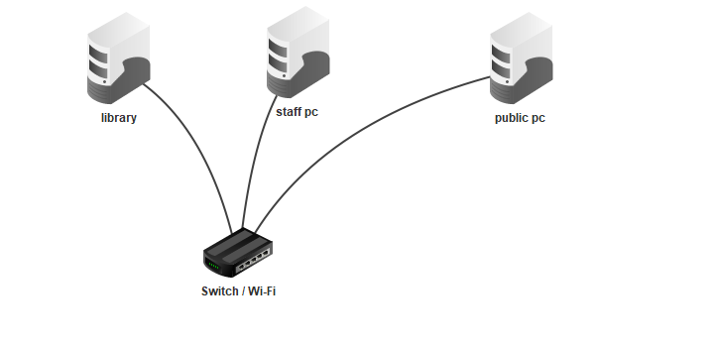

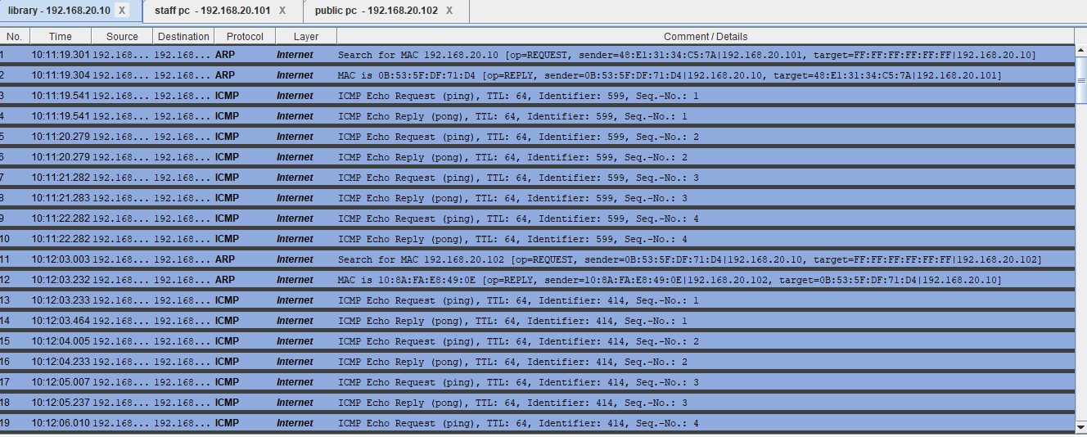

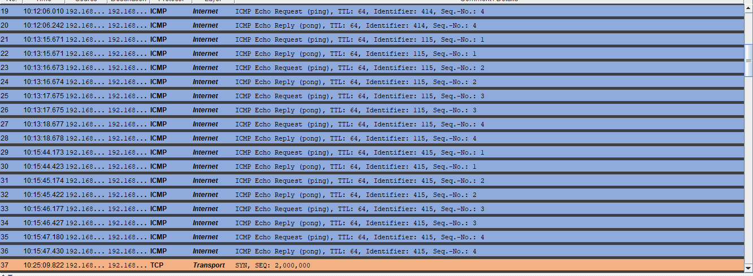
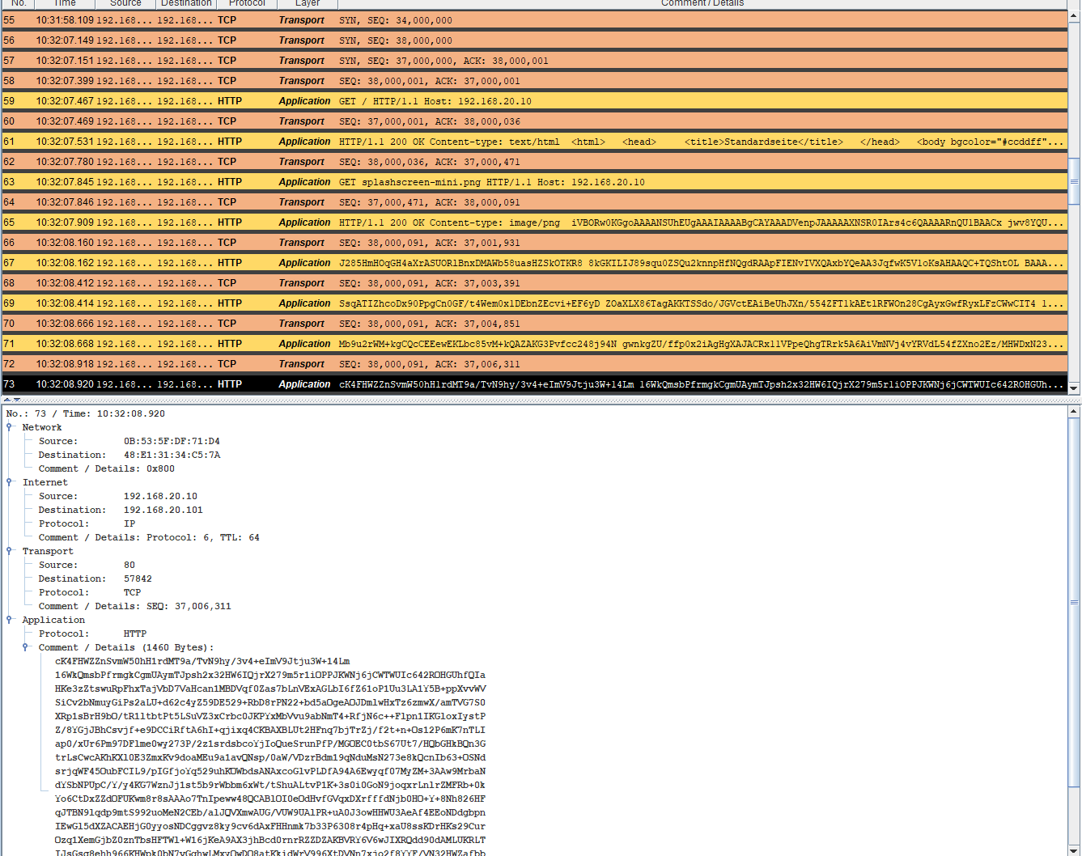
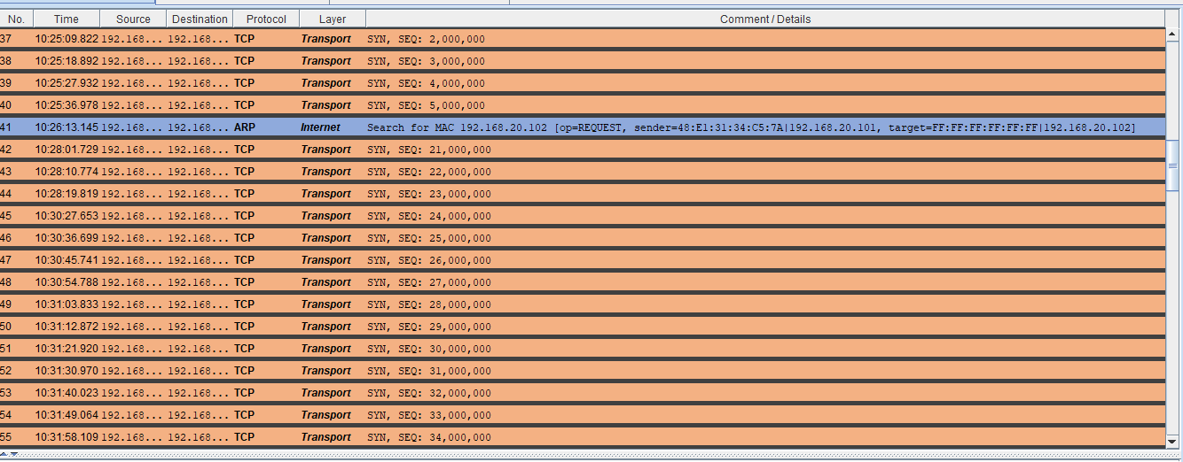
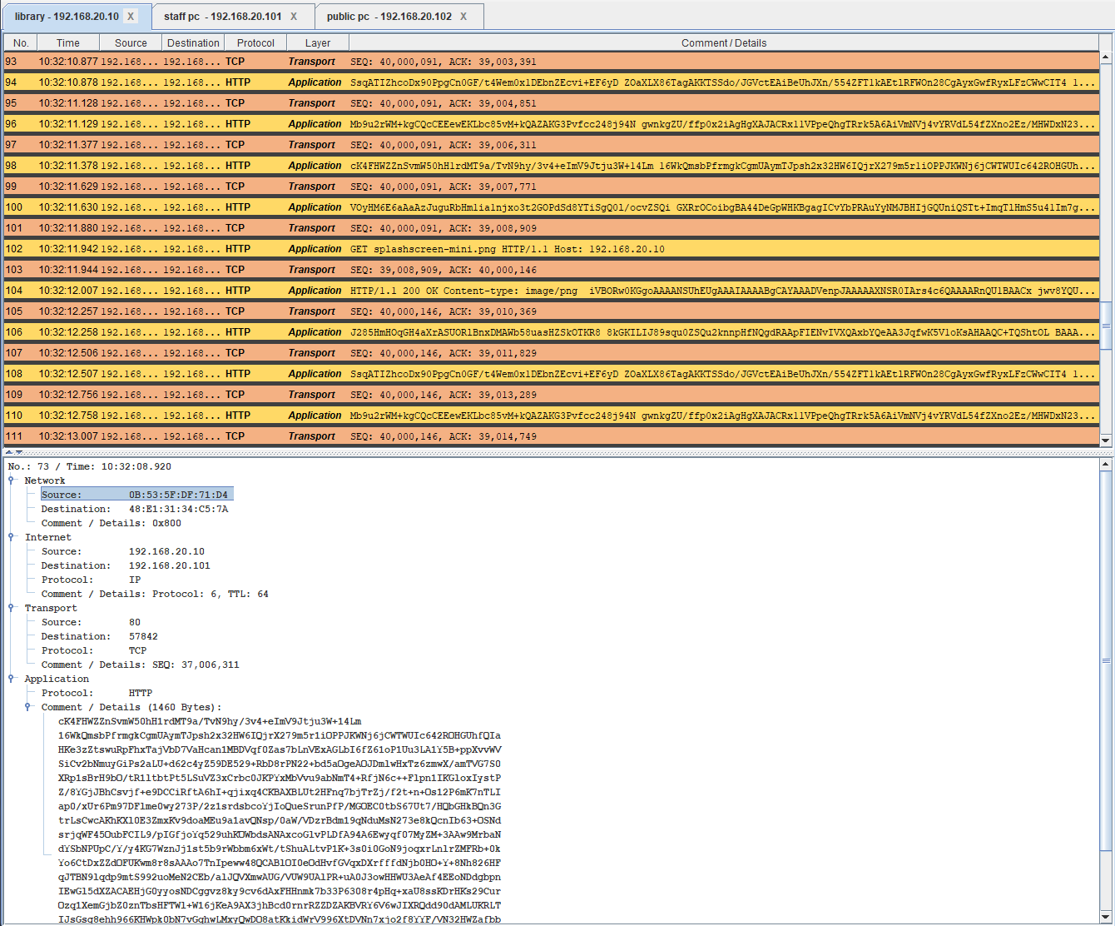
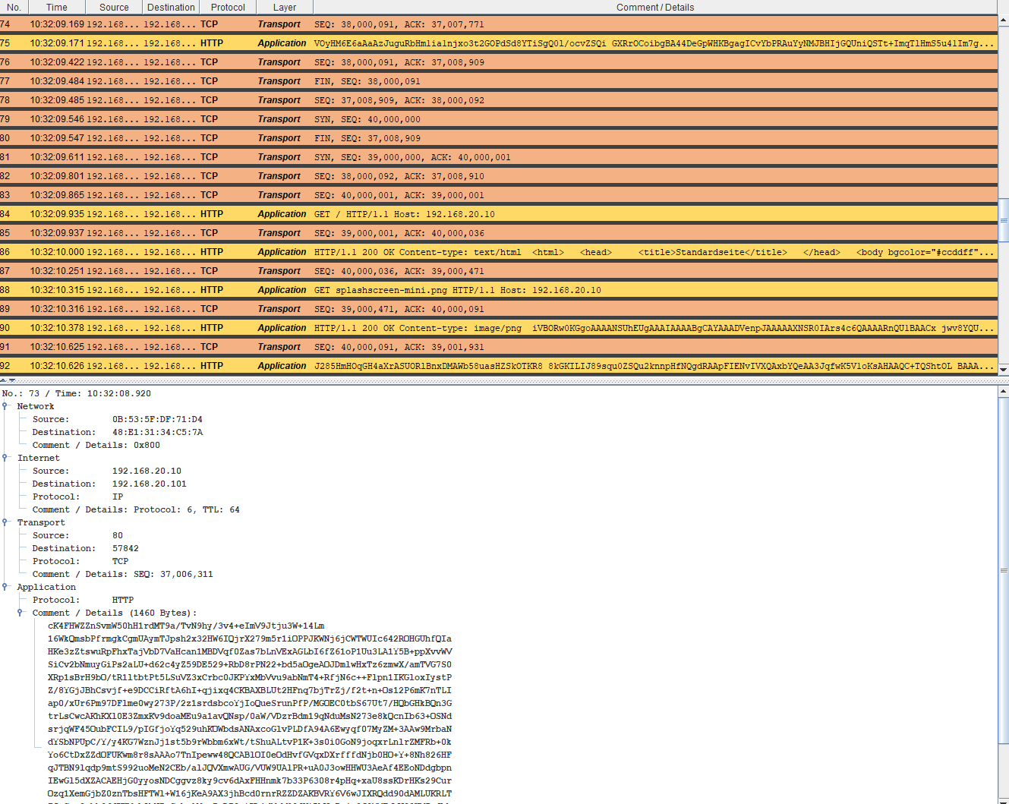
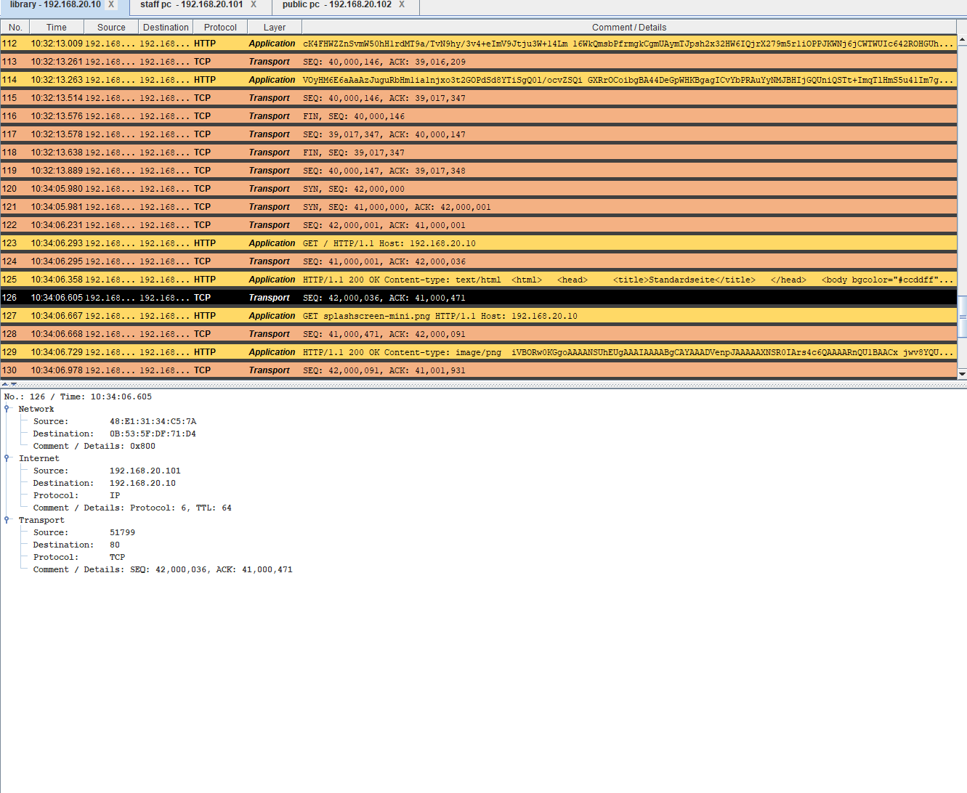
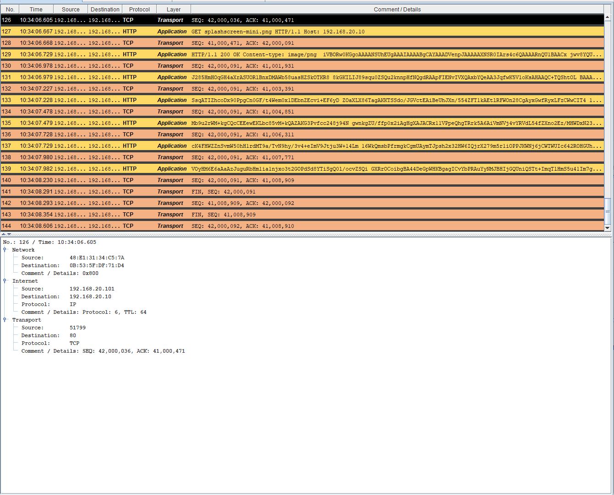

PROTOCOL | HOW TO MAKE IT APPAEAR | TOP LYAER REACHED | WHAT ITS DOING

ARP |  | NETWORK | Address Resolution Protocol; finds the MAC address for a known local IP.
ICMP |  | INTERNET | diagnostic/control protocol used by tools such as ping.​
TCP |  | TRNSPORT | reliable, connection-oriented transport; data arrives in order.​
HTTP |  | APPLICATION | sets the rules for how web browsers and web servers exchange data and display websites on the internet
DNS(ext.) |  | APPLICATION | Domain Name System; translates names such as google.com into IP addresses.

